

| Course Code | IPATLEC1 | Section | BSIT-3A |
| --- | --- | --- | --- |
| Course Details | Integrative Programming | Date | 29/1/23 |
| Name | De Guzman, Jay Ar D. | Student No. | 204-0138 |

Final Period Laboratory Exercises 1

**Decision Structure**

**Objectives**

* To understand the simple decision programming pattern and its implementation using a Python if statement.
* To understand the two-way decision programming pattern and its implementation using a Python if- else statement.
* To understand the multi-way decision programming pattern and its implementation using a Python if- else if- else statement.
* To understand the concept of Boolean expressions and the bool data type.
* To be able to read, write, and implement algorithms that employ decision structures, including those that employ sequences of decisions and nested decision structures.

**Programming Exercises**

1. One particular CS professor assigns five-point tests with a scaled grade. 5 A, 4 B, 3 C, 2 D, 1 F, and 0 F. Create a program that recognizes a test result as an input and determines the corresponding grade using a decision-making process.
2. A person's weight is used to calculate their body mass index (BMI) (in pounds) divided by the square of the person's height multiplied by 720 (in inches). A BMI 19 to 25 years old, inclusive, is regarded as healthy. Develop a program that determines a person's BMI and produces a message indicating their health over, through, or under the normal range.

**Source Code of the Program**

**Program exercise 1:**

**def studgrade(result):**

**if result == 5:**

**return "A"**

**elif result == 4:**

**return "B"**

**elif result == 3:**

**return "C"**

**elif result == 2:**

**return "D"**

**elif result == 1:**

**return "F"**

**else:**

**return "Invalid input. Please enter a number between 0-5."**

**def main():**

**res = int(input("Enter your test result: "))**

**grade = studgrade(res)**

**print("Your grade is:", grade)**

**main()**

**Program exercise 2**

**def BMI_calcu(weight, height):**

**bmi = weight / (height * height) * 720**

**if bmi >= 19 and bmi <= 25:**

**return "Your BMI is in the healthy range."**

**elif bmi < 19:**

**return "Your BMI is under the healthy range."**

**else:**

**return "Your BMI is over the healthy range."**

**def main():**

**user_weight = float(input("Enter your weight in pounds: "))**

**user_height = float(input("Enter your height in inches: "))**

**healthStatus = BMI_calcu(user_weight, user_height)**

**print(healthStatus)**

**main():**

**Screenshots of the output (Testing that the output is functional and accurate)**

**Program Exercise 1:**

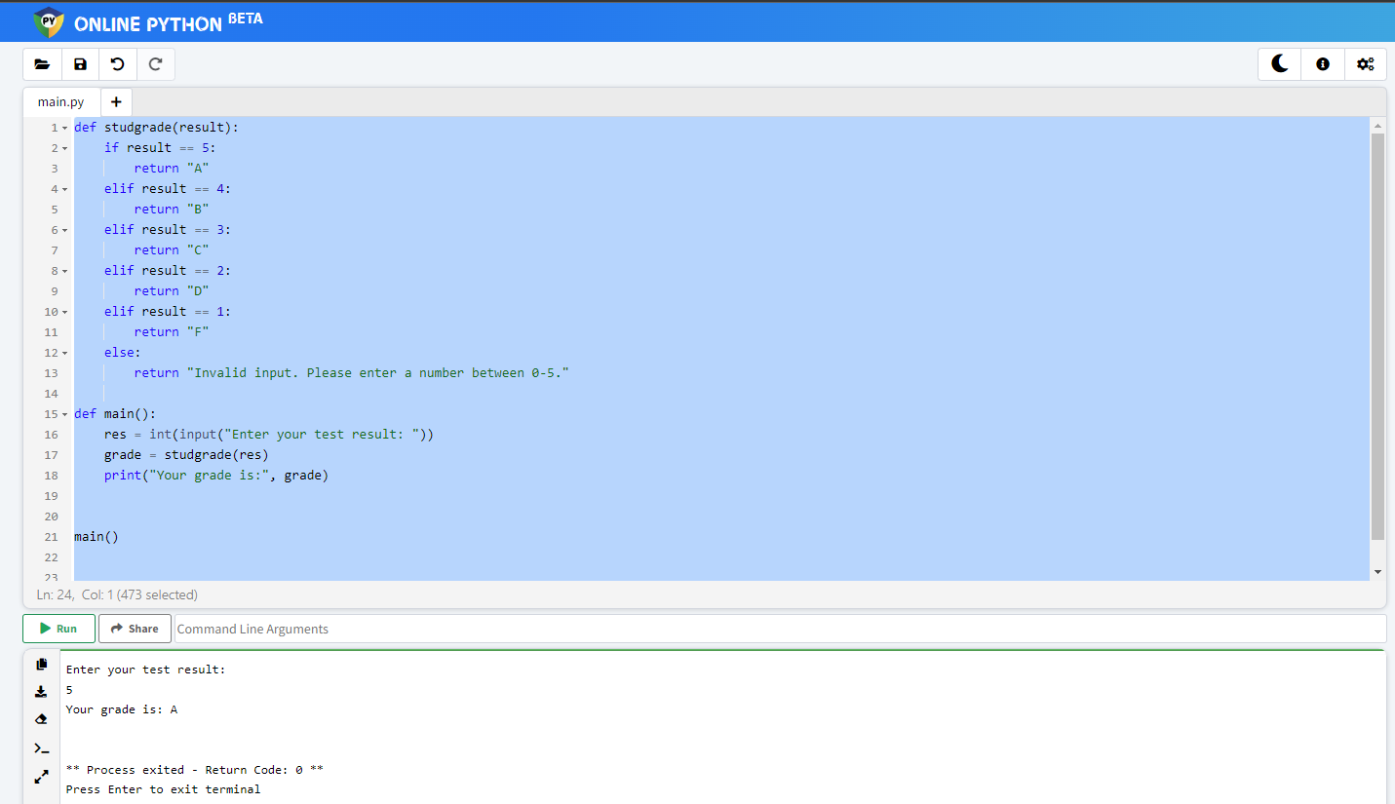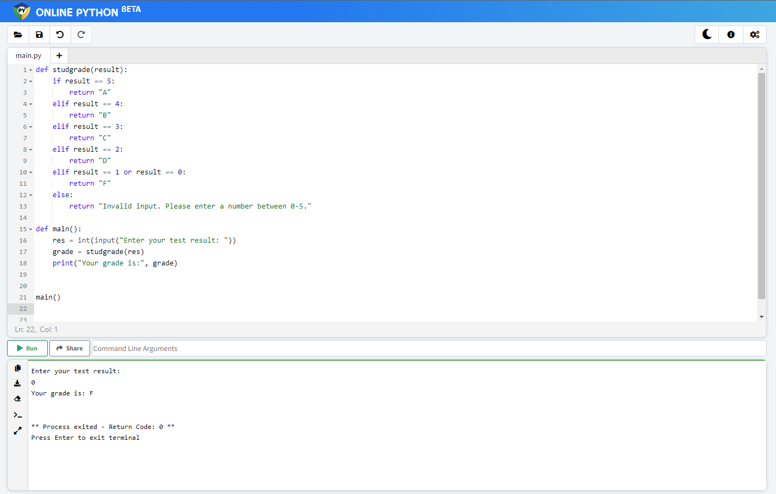

**Program Exercise 2:**

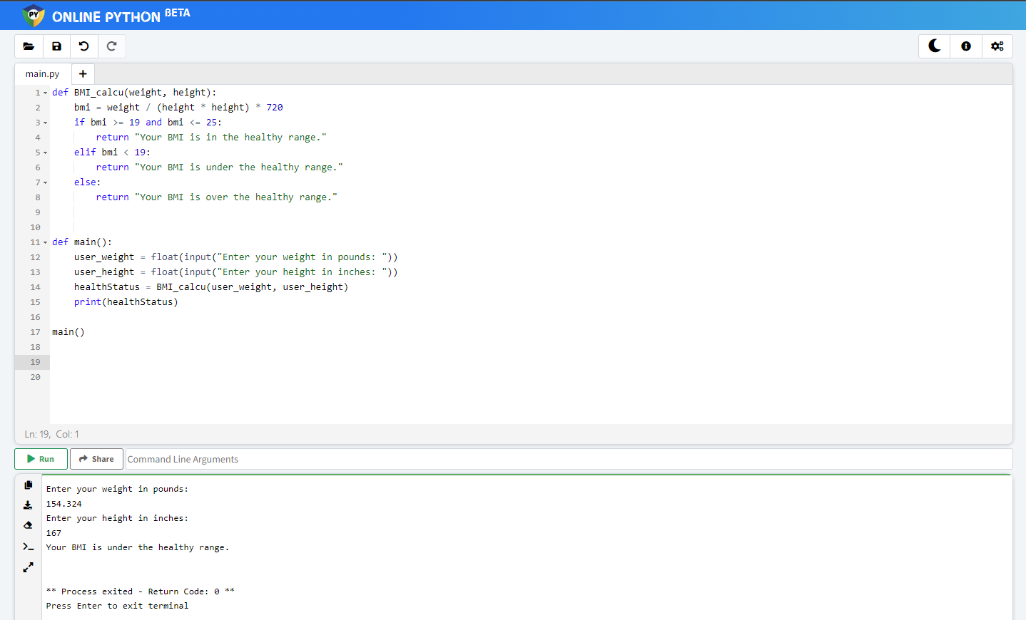

**Reflection to the given Programming Exercises**

how to use my logical thinking using else if statement